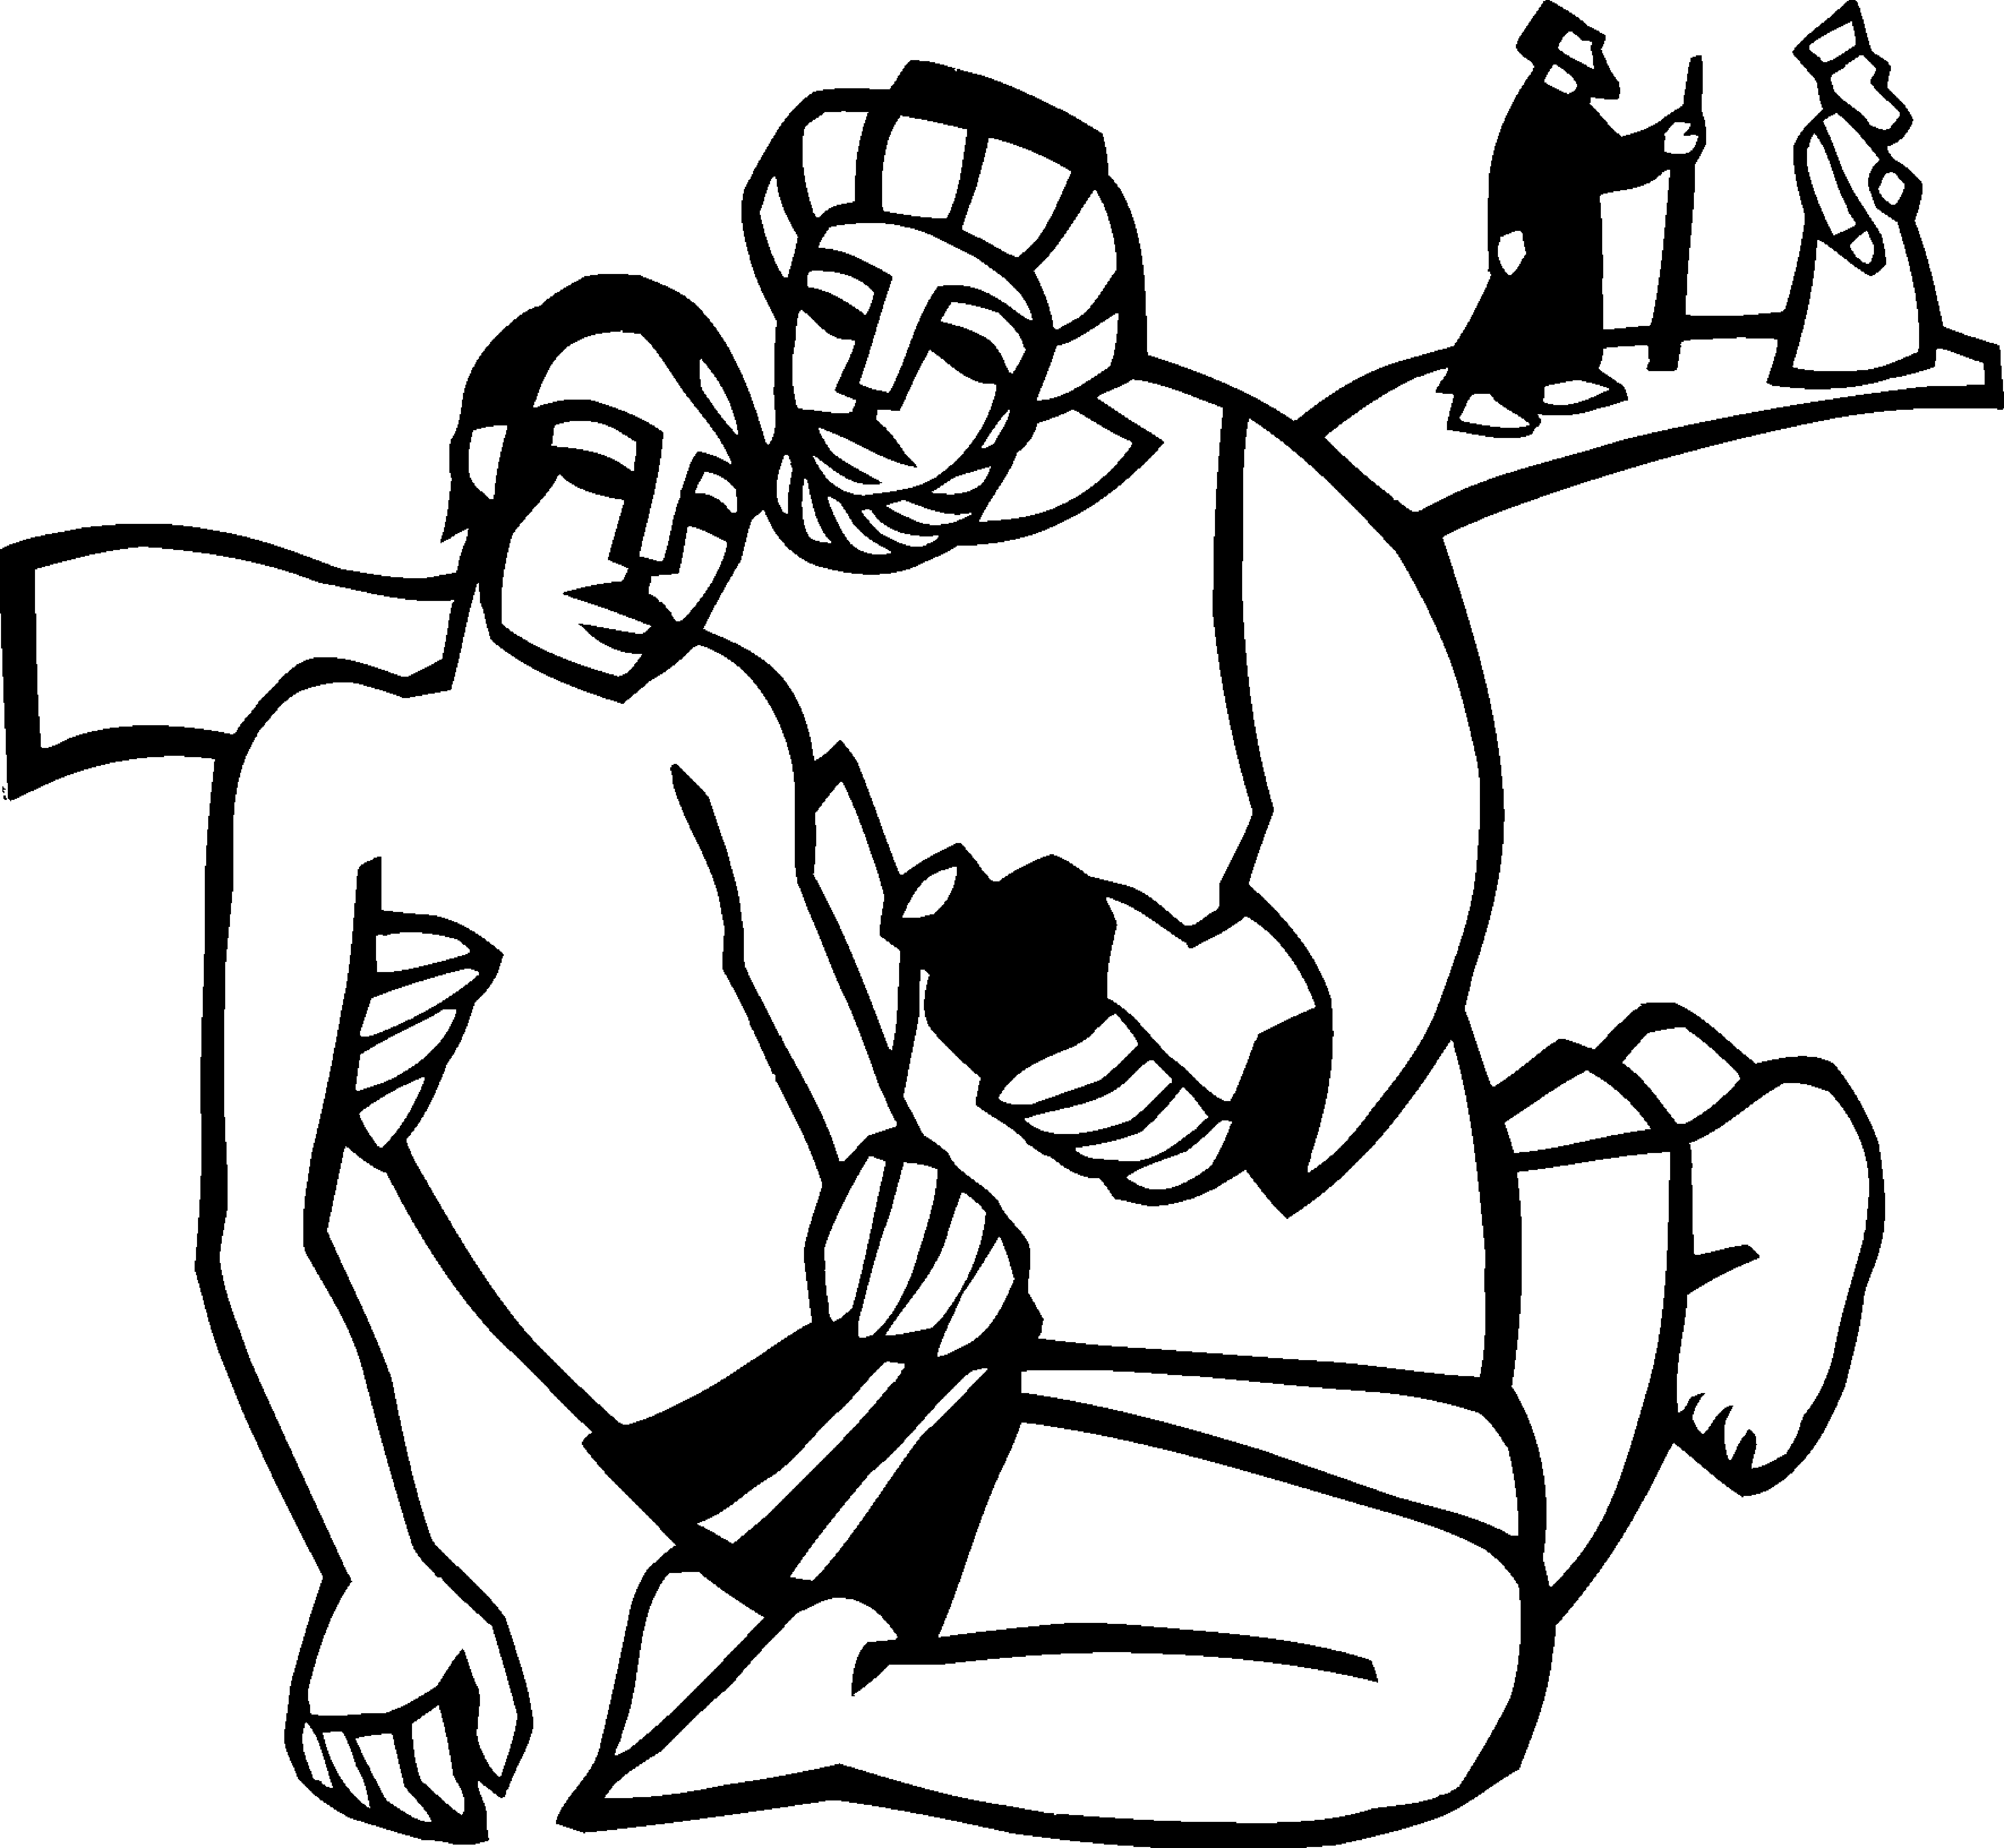
The 5th Sunday after Pentecost

July 13, 2025 Worship at 9:30 a.m.

Gathering

To love the Lord your God with all your heart, soul, strength, and mind is to reflect God’s mercy in responding to one’s neighbor. That mercy found its most profound expression in the “gospel that has come to you”—namely the life, death, and resurrection of Jesus Christ. That gospel mercy comes to us again today in the Word and Altar.

Our worship order is contained in this booklet. The people's parts are indicated by bold type. The red hardback hymnal, Evangelical Lutheran Worship, is our main worship resource for hymns and song. You can find hymns in the second half of the book, and are numbered at the top of each hymn. Occasionally, worship may veer from the printed bulletin – just follow the Spirit!

A warm welcome whether you are joining us in-house or by social media. Our prayer is that worship today will be a blessing as we sing and pray and hear God’s Word together. We welcome you to the Lord’s Table this morning. Christ Church is a family of faith deeply rooted in our upper Bucks communities, supporting one another in faith, working together to serve God.

Please take this weekly resource home with you – use it to take notes, jot down reminders, pray, remember dates. You can call (215.766.8730) or email (christpipersville@gmail.com) for prayer needs. In an emergency, please call the parsonage at 267-362-8129.

Welcome and Worship Announcements

The Prelude: time for prayer and preparation.

Please stand in body or spirit at Pastor’s invitation.

Blessed be the holy Trinity, ☩ Father, Son and Holy Spirit, one God,
Blessed be God forever! Amen.

Almighty God, to whom all hearts are open, all desires known, and from whom no secrets are hid: cleanse the thoughts of our hearts by the inspiration of your Holy Spirit, that we may perfectly love you and worthily magnify your holy name, through Jesus Christ our Lord. Amen.

Let us confess our sin in the presence of God and of one another.

Silence is kept for reflection.

Most merciful God, we confess that we are captive to sin and cannot free ourselves. We have sinned against you in thought, word, and deed, by what we have done and by what we have left undone. We have not loved you with our whole heart; we have not loved our neighbors as ourselves. For the sake of your Son, Jesus Christ, have mercy on us. Forgive us, renew us, and lead us, so that we may delight in your will and walk in your ways, to the glory of your holy name. Amen.

In the mercy of almighty God, Jesus Christ was given to die for us, and for his sake God forgives us all our sins. As a called and ordained minister of the church of Christ, and by his authority, I therefore declare to you the entire forgiveness of all your sins, in the name of the Father, and of the ☩ Son, and of the Holy Spirit. Amen.

Gathering Hymn ELW #532, Gather Us In

Greeting
The grace of our Lord, Jesus Christ, the love of God,
and the communion of the Holy Spirit be with you all. And also with you.

The Prayer of the Day
Let us pray. Silence. Pastor offers the Prayer of the Day. We join in our hearts. The prayer concludes: …our Savior and Lord. Amen.

Please be seated.

Word

The First Lesson is from Deuteronomy the 30th chapter. (Deuteronomy 30:9-14)

⁹ The Lord your God will make you abundantly prosperous in all your undertakings, in the fruit of your body, in the fruit of your livestock, and in the fruit of your soil. For the Lord will again take delight in prospering you, just as he delighted in prospering your ancestors, ¹⁰ when you obey the Lord your God by observing his commandments and decrees that are written in this book of the law, because you turn to the Lord your God with all your heart and with all your soul.
¹¹ “Surely, this commandment that I am commanding you today is not too hard for you, nor is it too far away. ¹² It is not in heaven, that you should say, ‘Who will go up to heaven for us and get it for us so that we may hear it and observe it?’ ¹³ Neither is it beyond the sea, that you should say, ‘Who will cross to the other side of the sea for us and get it for us so that we may hear it and observe it?’ ¹⁴ No, the word is very near to you; it is in your mouth and in your heart for you to observe.. The Word of the Lord. Thanks be to God.

+ Silence +
Psalm 25 is read responsively by verse. (Psalm 25:1-10)
¹ To you, O Lord, I lift up my soul.
² My God, I put my trust in you; let me not be put to shame,
nor let my enemies triumph over me.
³ Let none who look to you be put to shame;
rather let those be put to shame who are treacherous.
⁴ Show me your ways, O Lord,
and teach me your paths.
⁵ Lead me in your truth and teach me,
for you are the God of my salvation; in you have I trusted all the day long.
⁶ Remember, O Lord, your compassion and love,
for they are from everlasting.
⁷ Remember not the sins of my youth and my transgressions;
remember me according to your steadfast love
and for the sake of your goodness, O Lord.
⁸ You are gracious and upright, O Lord;
therefore you teach sinners in your way.
⁹ You lead the lowly in justice
and teach the lowly your way.
¹⁰ All your paths, O Lord, are steadfast love and faithfulness
to those who keep your covenant and your testimonies. Amen.

The Second Reading is from Colossians, the 1st chapter (Colossians 1:1-14)
¹ Paul, an apostle of Christ Jesus by the will of God, and Timothy our brother,
² To the saints and faithful brothers and sisters in Christ in Colossae:
Grace to you and peace from God our Father.
³ In our prayers for you we always thank God, the Father of our Lord Jesus Christ, ⁴ for we have heard of your faith in Christ Jesus and of the love that you have for all the saints, ⁵ because of the hope laid up for you in heaven. You have heard of this hope before in the word of the truth, the gospel ⁶ that has come to you. Just as it is bearing fruit and growing in the whole world, so it has been bearing fruit among yourselves from the day you heard it and truly comprehended the grace of God. ⁷ This you learned from Epaphras, our beloved fellow servant. He is a faithful minister of Christ on our behalf, ⁸ and he has made known to us your love in the Spirit.
⁹ For this reason, since the day we heard it, we have not ceased praying for you and asking that you may be filled with the knowledge of God’s will in all spiritual wisdom and understanding, ¹⁰ so that you may walk worthy of the Lord, fully pleasing to him, as you bear fruit in every good work and as you grow in the knowledge of God. ¹¹ May you be made strong with all the strength that comes from his glorious power, so that you may have all endurance and patience, joyfully ¹² giving thanks to the Father, who has enabled you to share in the inheritance of the saints in the light. ¹³ He has rescued us from the power of darkness and transferred us into the kingdom of his beloved Son, ¹⁴ in whom we have redemption, the forgiveness of sins. The Word of the Lord. Thanks be to God.

+ Silence +
Please stand, in body or spirit.

Gospel Acclamation ELW #174
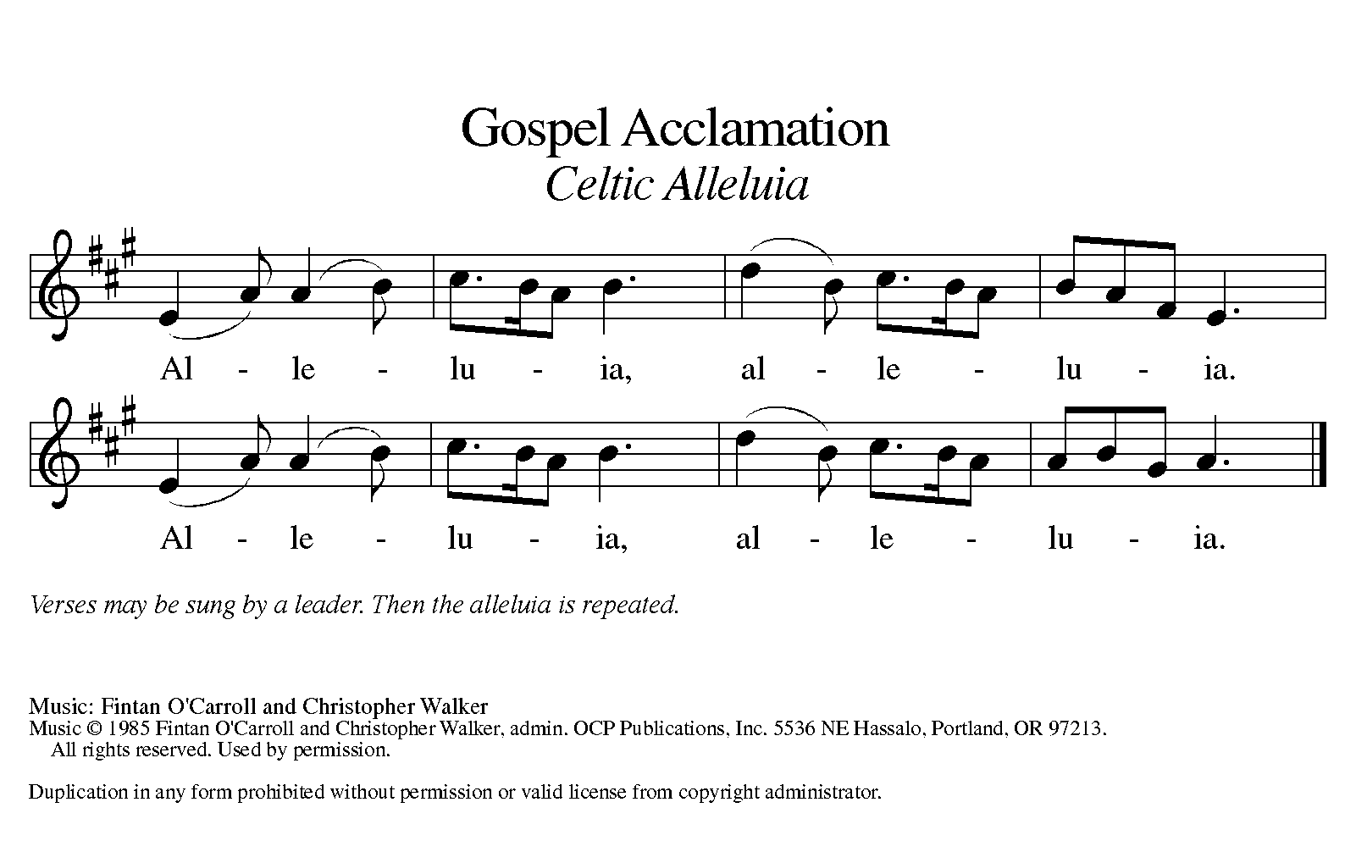

The Holy Gospel according to (Luke 10:25-37)
²⁵ An expert in the law stood up to test Jesus. “Teacher,” he said, “what must I do to inherit eternal life?” ²⁶ He said to him, “What is written in the law? What do you read there?” ²⁷ He answered, “You shall love the Lord your God with all your heart and with all your soul and with all your strength and with all your mind and your neighbor as yourself.” ²⁸ And he said to him, “You have given the right answer; do this, and you will live.”
²⁹ But wanting to vindicate himself, he asked Jesus, “And who is my neighbor?” ³⁰ Jesus replied, “A man was going down from Jerusalem to Jericho and fell into the hands of robbers, who stripped him, beat him, and took off, leaving him half dead. ³¹ Now by chance a priest was going down that road, and when he saw him he passed by on the other side. ³² So likewise a Levite, when he came to the place and saw him, passed by on the other side. ³³ But a Samaritan while traveling came upon him, and when he saw him he was moved with compassion. ³⁴ He went to him and bandaged his wounds, treating them with oil and wine. Then he put him on his own animal, brought him to an inn, and took care of him. ³⁵ The next day he took out two denarii, gave them to the innkeeper, and said, ‘Take care of him, and when I come back I will repay you whatever more you spend.’ ³⁶ Which of these three, do you think, was a neighbor to the man who fell into the hands of the robbers?” ³⁷ He said, “The one who showed him mercy.” Jesus said to him, “Go and do likewise.” The Gospel of our Lord. Praise to you, O Christ!

The alleluia repeats. Please be seated.

Teaching the Word / Sermon

Hymn of the Day ELW #722, O Christ Your Heart
Meal
I ask you to confess your faith, in the words of the Apostles’ Creed.

I believe in God, the Father almighty,
creator of heaven and earth.
I believe in Jesus Christ, God’s only Son, our Lord,
who was conceived by the Holy Spirit,
born of the virgin Mary,
suffered under Pontius Pilate,
was crucified, died, and was buried;
he descended to the dead.

On the third day he rose again;
he ascended into heaven,
he is seated at the right hand of the Father,
and he will come to judge the living and the dead.

I believe in the Holy Spirit,
the holy catholic church,
the communion of saints,
the forgiveness of sins,
the resurrection of the body,
and the life everlasting. Amen.

The Prayers
With the whole people of God in Christ Jesus let us pray for healing and wholeness for all in need, for Christ’s Body, the church and all of God’s creation.
A brief silence.
We pray for the world, our community, and our church. Each petition concludes with: …in your mercy, Hear our prayer. We are invited to pray for the needs of our hearts with the words: ‘…people of God, for what else shall we pray?’

Into your hands, gracious God, we commend all for whom we pray, trusting in your mercy; through Jesus Christ, our Savior. Amen.

The Peace
The peace of the Lord be with you always. And also with you.

We greet one another in peace saying, “Peace be with you” or similar words. Feel free to step out of your pew! Following the peace, please be seated.

Offertory, as We Gather Our Tithes and Offerings / Anthem

We offer our love, obedience and lives in thanksgiving as a response to God’s gifts and mercies. If you are worshipping remotely tithes and offerings may be gathered and given by mail, online at christpipersville.org or using the QR code. The Table is prepared.

Offertory Response Please stand as the song begins.
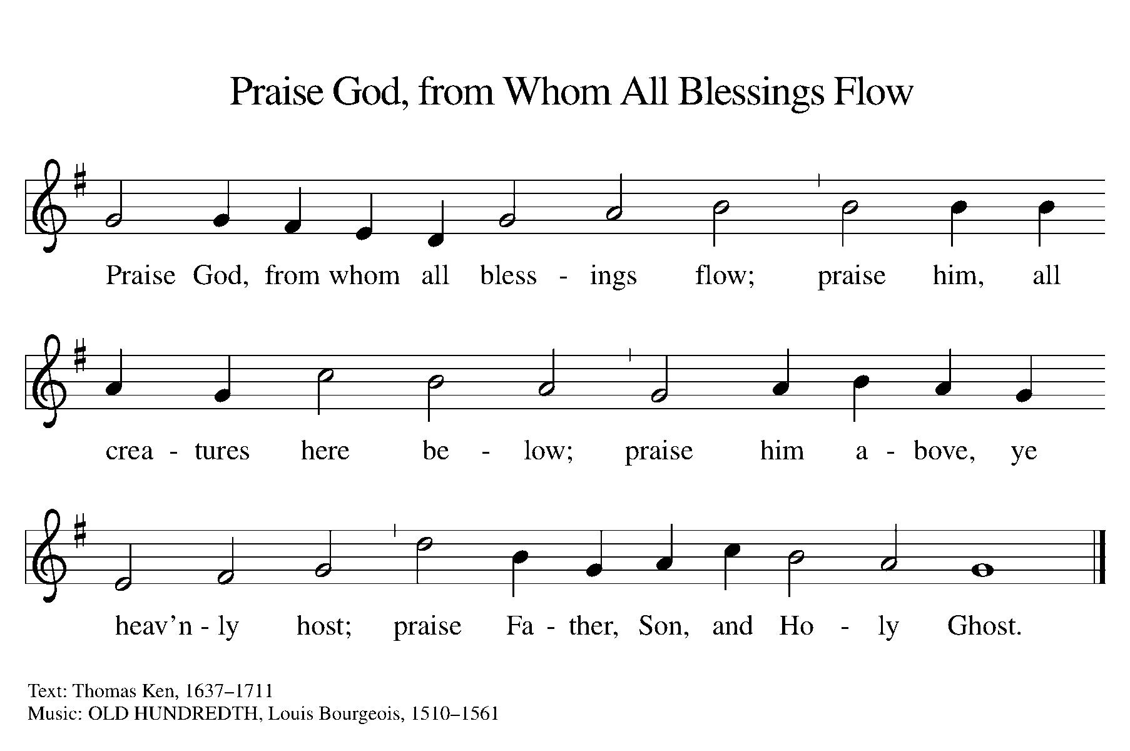

Offertory Prayer
Let us pray. a brief silence Holy God, gracious and merciful:
you bring forth food from the earth and nourish your whole creation. Turn our hearts toward those who hunger in any way, that all may know your care; and prepare us now to feast on the bread of life, Jesus Christ, our Savior and Lord.
Amen.

Great Thanksgiving

The Lord be with you. And also with you.

Lift up your hearts. We lift them to the Lord.

Let us give thanks to the Lord our God.
It is right to give our thanks and praise.

It is right and a joyful thing to give you thanks O God,
holy, almighty and merciful …

Pastor offers the Eucharistic prayer; we join in our hearts. The prayer concludes:

…With the whole people of God, we give thanks
praying with trust and hope for the coming of the Kingdom
in the words our Savior taught us:

Our Father, who art in heaven,
hallowed be thy name,
thy kingdom come,
thy will be done on earth as it is in heaven.
Give us this day our daily bread;
and forgive us our trespasses,
as we forgive those who trespass against us;
and lead us not into temptation,
but deliver us from evil.
For thine is the kingdom,
and the power, and the glory,
forever and ever. Amen.

Agnus Dei
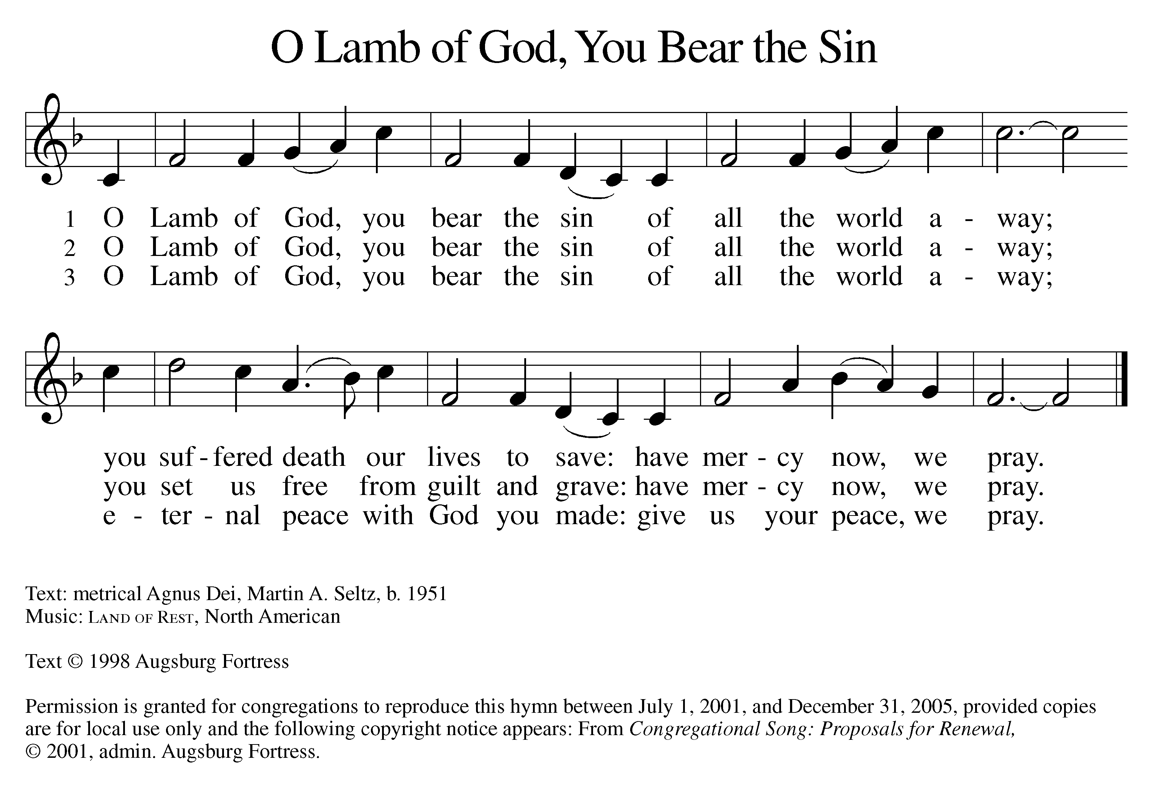

Invitation to Communion

My brothers and sisters, come to the Table, for all is ready!
We shall come with joy, alleluia, amen!

We share in the Lord’s Body and Blood. We believe the risen Christ is truly present in the forms of bread and wine to forgive, renew and strengthen. All are welcome-this is the Lord’s Table and He invites you! If you have taken an elements cup and prefer to commune where you are seated, please do so at any time after the invitation. The elements are offered with the words: ‘The Body of Christ given for you” and “The Blood of Christ shed for you”. The recipient may respond “Amen”.

The musicians and other assistants will be communed first, followed by those online. Then the congregation comes forward by the center aisle, the organ side first, and then the pulpit side. Receive the Host (bread) from Pastor, with the words, ‘The body of Christ, given for you.’ The assistant offers the chalice of wine for intinction, (dipping the bread into the wine) with the words: ‘The blood of Christ, shed for you. The communicant may say: Amen. Please return to your pew by the side aisle. Anyone, child or adult, who does not wish to take communion is invited to come forward, hands folded, to receive a blessing, or remain seated and commune by prayer. The communion song,- - - is sung.

When all have communed and the Table is cleared, please stand at Pastor’s invitation.

The body and blood of our Lord Jesus Christ strengthen you
and keep you in his grace. Amen.

Silence
The Post-Communion Prayer
O God, our life, our strength, our food: we give you thanks for sustaining us with the body and blood of your Son. By your Holy Spirit enliven us to be Christ’s body in the world, that our words and action praise You serving your creation and all peoples as witnesses to Jesus Christ, our Savior and Lord. Amen.

Please be seated for Mission & Ministry Announcements.

Sending

Please stand in body or spirt at Pastor’s invitation.

The Benediction
The Almighty God, Father, Son and Holy Spirit bless you now and forever. Amen.

Sending Hymn, ELW #836, Joyful Joyful

The Dismissal
Go in peace, serve the Lord.
Thanks be to God.

The Postlude
Christ Evangelical Lutheran Church
353 E. Dark Hollow Rd
Pipersville PA 18947
215. 766. 8730 office
267. 362. 8129 parsonage

The Rev. Marie L. Caron, pastor
the people of Christ Church, ministers
Mrs. Cindy Carper, Secretary
Mr. Brian Maddux, Council President

Worship Acknowledgments and Credits:
The ordo is the traditional liturgy of Holy Communion.
ELW is Evangelical Lutheran Worship
Propers of the Day, Introduction and Propers Copyright © 2025 Augsburg Fortress, New Revised Standard Version Bible, Copyright © 1989, Division of Christian Education of the National Council of the Churches of Christ in the United States of America. Used by permission. All rights reserved.

Hymns not in the public domain reprinted and streamed by permission in accord with licenses OneLicense #A-711138 and CCLI #1475937.

